The Islamia University of Bahawalpur
Department of information technology

SOFTWARE REQUIREMENTS SPECIFICATION

(SRS DOCUMENT)

for

Multi-Vendor E-Commerce Web App with LLM Integration
Version 1.0

By

ASAD JILLANI

ROLL.NO F22BINFT1E02074
Session Fall 2022 – 2026

Supervisor

DR.MUHAMMAD ASADULLA

Bachelor of information technology

Table of Contents
Revision History 1
Application evaluation History 2
Introduction 3
Purpose 3
Scope… 3
Product perspective 3
Operating environment 4
Overall description 4
Functional requirement 6
Functional requirement X 6
Non-Functional requirement 7
Usability 7
Performance 7
Requirement identifying technique 8
Use case diagram 8
Use case description 9
References 9

Revision History

Name | Date | Reason for changes | Version

Application Evaluation History

Comments (by committee)  *include the ones given at scope time both in doc and presentation | Action Taken

Supervised by

DR.MUHAMMAD ASAD-ULLAH

Signature

Introduction
Time has definitely witnessed the rise of digital commerce and with every passing day more and more is being popularized as companies as well as customers are all influenced. An E-Commerce Web Application is simply where customers can shop, use to acquire products, complete purchase order, and track orders online. In this paper, we identify the specifications needed to build such an application in Django Framework with sound programming principles and for securing and scalability. It has two sections the customer interface and the admin interface. Customers will be able to view an online catalogue, add items to the shopping cart, pay via secure payment gateways. Amongst other things, owners and administrators will be able to manage products and orders with an easy-to-use administration panel so they can also control user accounts. Features such as product search, order tracking, notifications will assist in avoiding the creation of complex problems related to the shopping process being introduced in the system. The platform will be designed today using current technologies and will be fast, secure and will be available to users on all types of devices. This SRS specifies exactly how to build the system according to requirements, and in turn is based on them.

Purpose
This document is written in order to provide software requirements of an E-Commerce Web Application. With this system a user is able to browse through products, put products in the cart, make secure payments and also manage the order. Django is a Python based web framework which will be used for developing this system to ensure scalability, security as well as ease of user-friendly interaction.

Scope
This Multi-Vendor E-Commerce web application will provide the following features:
- Separate registration and dashboard for Customers and Vendors.
- Vendor registration approval by Admin.
- Vendors can add/manage their own products, view orders, and monitor earnings.
- Customers can browse, filter, and purchase from a shared product catalog.
- Secure payments processed per vendor (split payment architecture via Stripe/PayPal).
- Admin can manage all users, products, orders, and commissions.
- Full LLM-based chatbot powered by GPT for personalized support and product recommendations.
- Mobile responsive and scalable for high user traffic.

Product Perspective
This application serves as a multi-vendor marketplace where:
- Multiple vendors can sell products via their vendor-specific dashboards.
- Customers can purchase products from one or more vendors in a single order.
- Admin manages users, vendors, commissions, and platform-wide policies.
- AI-powered chatbot (based on LLM like GPT) assists users in real-time for queries, FAQs, and smart product suggestions.

Operating Environment
  - Frontend: HTML, CSS, JavaScript (Bootstrap for responsiveness).
  - Backend: Django Framework (Python).

  - AI chatbot: LLM
  - Database: PostgreSQL/MySQL.
  - Deployment: Cloud-based (AWS or Digital Ocean).
  - Payment Integration: Stripe, PayPal,etc
  - Browser Compatibility: Google Chrome, Mozilla Firefox, Safari, Edge.

Design & Implementation Constraints
- System must be developed using the Django Framework.
- Frontend must be mobile responsive (Bootstrap or similar).
- Must support multiple browsers (Chrome, Firefox, Safari, Edge).
- Integrate with PCI-DSS compliant payment gateways (e.g., Stripe, PayPal).
- Ensure secure user data handling with SSL/TLS and hashed passwords.
- Role-based access control for customers, vendors, and admins.
- Stable internet connection required for seamless functionality.
- Payment APIs and email services must be functional for transactions and notifications.

Overall Description
User Classes and Characteristics
  - Customers: Browse and purchase products, manage profiles, chat with AI assistant.
  - Vendors: Register as sellers, list products, view/manage orders, withdraw earnings.
  - Admins: Approve vendors, manage products/orders/users, view platform analytics.
  - AI Assistant (LLM): Responds to user queries, recommends products, handles FAQs, escalates to human if needed.

Customers
  - Browse products from multiple vendors and add them to a shared shopping cart.
  - Place orders containing products from one or more vendors.
  - View and manage profile details including shipping address and payment history.
  - Track order status (Pending, Shipped, Delivered) per item/vendor.
  - Submit product ratings and written feedback after purchase.
  - Get smart assistance from the LLM-powered AI chatbot (e.g., product recommendations, return policy).

Vendors
- Register and wait for admin approval before becoming active sellers.
- Manage their own product listings (add/update/delete).
- View and manage orders related to their products.
- Track earnings, request withdrawals, and view commission deductions.
- Update store profile (e.g., contact details, store logo).
- Receive notifications about new orders and low stock alerts.
- Receive customer feedback and respond to product queries (optional).

Administrators
- Manage all platform users: customers, vendors, and guests.
- Approve/reject vendor registration requests.
- Moderate and manage the entire product catalog across vendors.
- Process vendor withdrawal requests and monitor commission reports.
- Manage chatbot content, escalation triggers, and logs.
- Oversee the system’s performance, backups, and maintenance activities.

Guest Users
- Browse the full product catalog across vendors.
- Use filters, search, and categories to discover products.
- Interact with the AI chatbot for basic queries and product recommendations.
- Must sign up to place orders or access personal features.

AI Chatbot (LLM-Powered)
- Responds to natural language queries such as:
- "What’s the return policy for Vendor X?"
- "Recommend a budget laptop under 100,000 PKR."
- Helps users locate specific products or categories.
- Offers personalized suggestions based on browsing history or preferences.
- Escalates complex issues to human support (e.g., order disputes).
- Accessible to both guests and registered users across all devices.

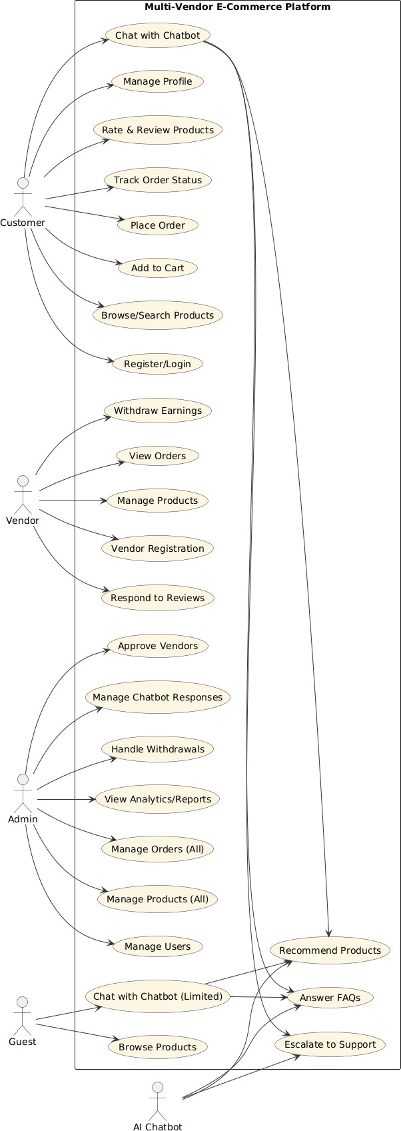
Use Case Diagram

Use Case 1: Customer Registration
Use Case | Customer Registration
Actor | Customer
Description | Allows users to register a new account.
Precondition | User provides valid email and password.
Postcondition | Account is created and user is logged in.
Main Flow | - Visit registration page  - Enter credentials  - Submit  - Get confirmation email
Alternative Flows | Email already exists → show error.
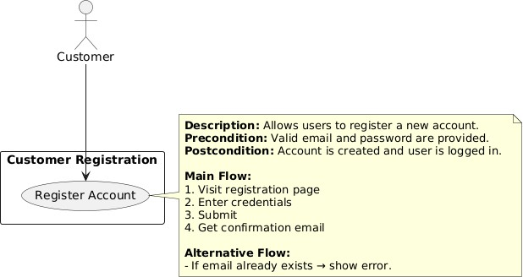

Use Case 2: Vendor Registration
Use Case | Vendor Registration
Actor | Vendor
Description | Vendor signs up and submits business details.
Precondition | Vendor fills required fields correctly.
Postcondition | Vendor is added to pending approval list.
Main Flow | - Fill form  - Submit  - Await approval
Alternative Flows | Missing info → prompt correction.
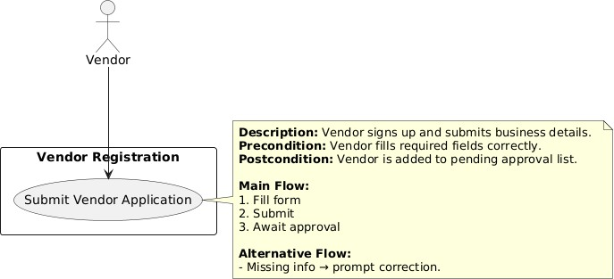

Use Case 3: Browse/Search Products
Use Case | Browse/Search Products
Actor | Customer, Guest
Description | Users search or browse product catalog.
Precondition | System has product data.
Postcondition | Matching results are displayed.
Main Flow | - Type in search or apply filter  - Results appear
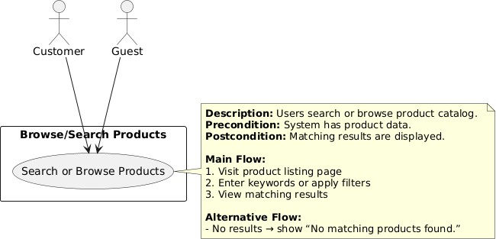

Use Case 4: Add to Cart
Use Case | Add Product to Cart
Actor | Customer
Description | Adds selected product to shopping cart.
Precondition | Product must be in stock.
Postcondition | Product added to cart.
Main Flow | - Click “Add to Cart”  - Confirm quantity

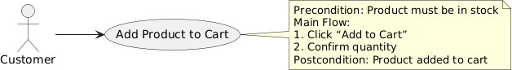

Use Case 5: Place Order
Use Case | Place Order
Actor | Customer
Description | Places an order from items in the cart.
Precondition | Cart has at least one item.
Postcondition | Order is created and payment is initiated.
Main Flow | - View cart  - Proceed to checkout  - Select payment method  - Confirm
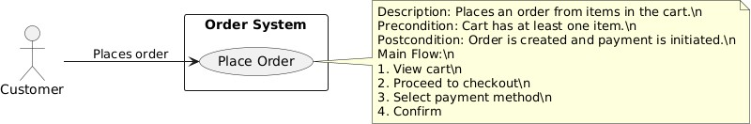

Use Case 6: Track Order
Use Case | Track Order Status
Actor | Customer, Vendor
Description | View status of placed orders.
Precondition | User must be authenticated.
Postcondition | Order status is shown.
Main Flow | - Navigate to orders  - View current status
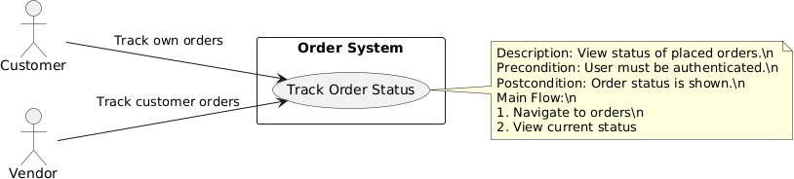

Use Case 7: Manage Products
Use Case | Manage Products
Actor | Vendor, Admin
Description | Add/edit/delete product listings.
Precondition | Vendor is approved and logged in.
Postcondition | Product catalog is updated.
Main Flow | - Open product manager  - Add or update details
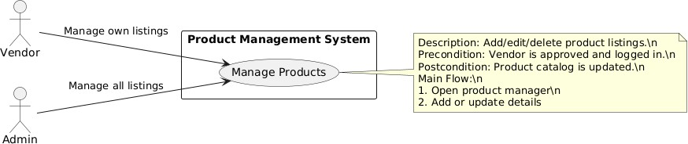

Use Case 8: Withdraw Earnings
Use Case | Withdraw Vendor Earnings
Actor | Vendor
Description | Requests withdrawal of available balance.
Precondition | Vendor has available funds.
Postcondition | Withdrawal request is submitted for approval.
Main Flow | - Navigate to “Earnings”  - Click withdraw  - Confirm bank info
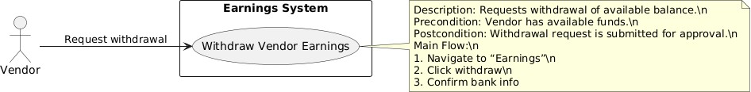

Use Case 9: Approve Vendor
Use Case | Approve Vendor Registration
Actor | Admin
Description | Approves or rejects vendor applications.
Precondition | Vendor has applied.
Postcondition | Vendor becomes active or rejected.
Main Flow | - Admin views list  - Reviews application  - Clicks approve/reject
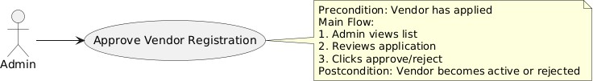

Use Case 10: Chat with Chatbot
Use Case | Chat with AI Chatbot
Actor | Customer, Guest
Description | Interact with chatbot for assistance.
Precondition | Chatbot is available and trained.
Postcondition | User receives help or escalates to support.
Main Flow | - Click chat icon  - Ask question  - Get intelligent response


Functional Requirements

Identifier | FR-1
Title | Register as Vendor
Requirement | The system shall allow users to register as vendors by submitting necessary business and contact information.
Source | UC-Register Vendor
Rationale | Enables onboarding of new sellers to the platform.
Business Rule | BR-1: Vendor applications must be approved by admin.
Dependencies | None
Priority | High

Identifier | FR-2
Title | List Product
Requirement | Approved vendors shall be able to add new product listings with images, descriptions, prices, and stock.
Source | UC-ManageProducts
Rationale | Supports catalog growth and product availability.
Business Rule | BR-2: Products must be reviewed for compliance before being published.
Dependencies | FR-1
Priority | High

Identifier | FR-3
Title | Place Order
Requirement | Customers shall be able to place orders for items added to their shopping cart.
Source | UC-PlaceOrder
Rationale | Core functionality to enable purchases.
Business Rule | BR-3: Orders must have at least one valid item and a confirmed payment method.
Dependencies | FR-2
Priority | High

Identifier | FR-4
Title | Track Order Status
Requirement | Customers and vendors shall be able to view the current status of orders.
Source | UC-TrackOrderStatus
Rationale | Improves transparency and user experience.
Business Rule | BR-4: Only authenticated users can access order history.
Dependencies | FR-3
Priority | Medium

Identifier | FR-5
Title | Manage Product Listings
Requirement | Vendors and admins shall be able to add, edit, or delete product listings.
Source | UC-ManageProducts
Rationale | Keeps the catalog accurate and up to date.
Business Rule | BR-5: Only approved vendors or admins can modify listings.
Dependencies | FR-1
Priority | High

Identifier | FR-6
Title | Withdraw Vendor Earnings
Requirement | Vendors shall be able to request withdrawal of their available earnings.
Source | UC-WithdrawVendorEarnings
Rationale | Supports vendor revenue management.
Business Rule | BR-6: Withdrawals require verified bank details and admin approval.
Dependencies | FR-3
Priority | Medium

Identifier | FR-7
Title | AI Chatbot Support
Requirement | The system shall provide a chatbot interface to assist users with questions or issues.
Source | UC-ChatWithAIChatbot
Rationale | Improves support accessibility and reduces response time.
Business Rule | BR-7: Chatbot must provide option to escalate to live support.
Dependencies | None
Priority | Medium

User Registration, User Authentication

Users must be able to register using their email and password. The system must also support secure log in and log out. They must also be able to reset their password through email. The access to managing the system is role based.

Product Management
Adding, updating, and deleting products have to be possible for admins. Name, price, description, category, stock, images are the details we need to include in an item, and products should have those details. Users can search and filter products by names, by category and price. It should be displayed the product ratings and reviews.

Shopping Cart
We need to'think of product addition to cart or product removal from cart' as a function for the users. The product quantity in the cart must be updateable by users. The total price must be dynamically displayed on the cart.

Order Management

After payment confirmation users should be able to place orders. The business needs to generate order receipts and send them via email. Order status users should be able to track (Pending, Shipped, Delivered). Admins must be able to change order status.

Payment Integration
The system has to work with payment gateways (such as Stripe, PayPal). The payment details must be

processed securely and securely stored. Payment and transaction receipts must be sent to users.

Notifications
The system must send email notifications for:

Order confirmation.

Payment receipts.

Order status updates. New orders should notify admins.

User Profile Management
Users must be able to change their personal details (name, address, contact info), 7.2 Users must be able to view their order history.

Feedback and Ratings
Users are to rate and give feedback about product, 8.2 Ratings should be visible on the product page.

Non-Functional Requirements

Performance Requirements

It has to respond to the user within 3 to 5 seconds. It must be handled by the system of 1000+ concurrent users without performance degradation.

Security Requirements
All sensitive data has and must be encrypted using SSL/TLS. Password are hashed to and stored securely. In reality, PCI-DSS standards must be adhered to by payment transactions. To implement role based access control, the system must be such.

Usability Requirements
For all devices the system needs to have an intuitive and responsive design. It must also support multiple languages (optional).

Availability Requirements
The system needs to have 99.9% uptime. Data loss is to be prevented by doing regular backups.

Maintainability Requirements

And, to permit easy updates and maintenance, the system must be modular. Developers and their admins need to have comprehensive documentation.

(

1. References
Django Official Documentation: https://docs.djangoproject.com/ Stripe API Documentation: https://stripe.com/docs

